**ECEN 4638 Lab 8 Part 1**

Before building, the plant was simulated in several different ways. MATLAB was used to plot frequency response of the given transfer function. The MATLAB code is shown below, along with the resulting MATLAB figure.

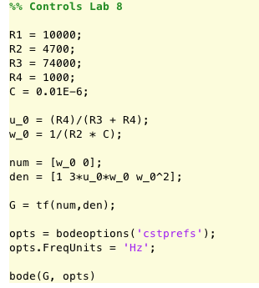

Figure : MATLAB code for finding system's frequency response

In addition to MATLAB plots, the system was simulated in LTSpice in order to verify that it would match up with the MATLAB representation.

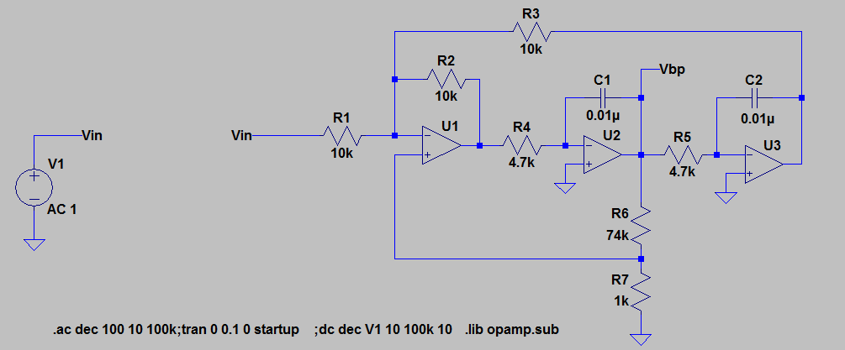

Figure : LTSpice circuit simulation

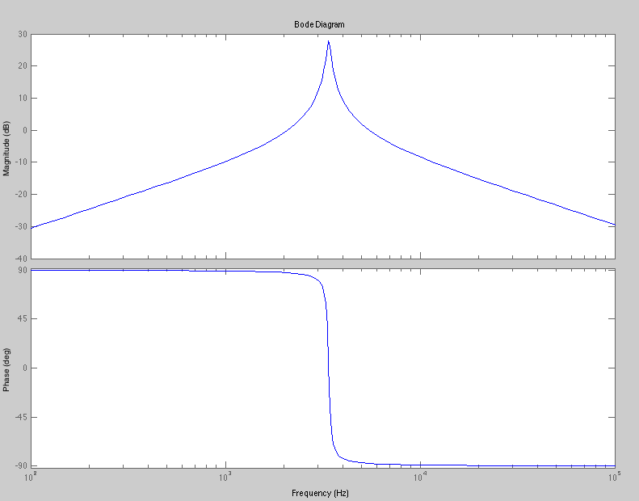

Figure : MATLAB plots of frequency response

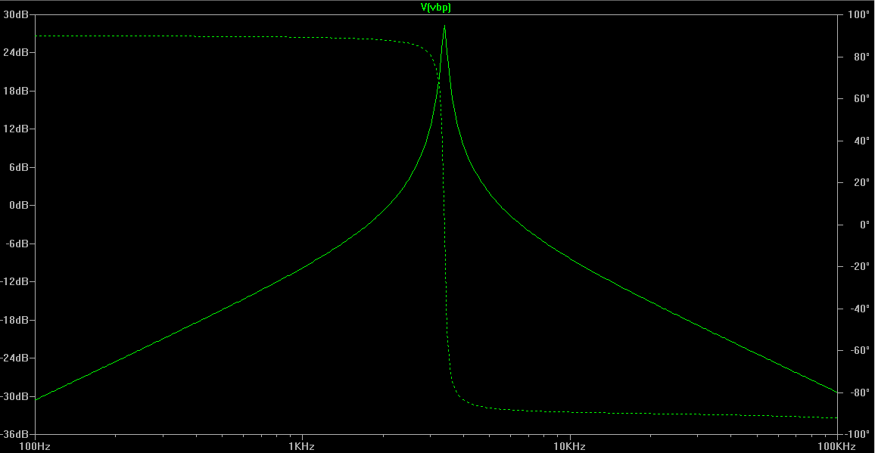

Figure : LTSpice simulation results

Both the LTSpice and MATLAB results aligned well enough to move ahead and construct the physical circuit. The circuit was constructed on a breadboard, and powered with ±12V. The input was a 1Vpp sine wave of varying frequency, and the output was measured with an oscilloscope set to 1X attenuation. The scope’s measurement functions were used to measure Vpp, frequency, and phase relative to the input signal. Figures 5-7 illustrate the setup.

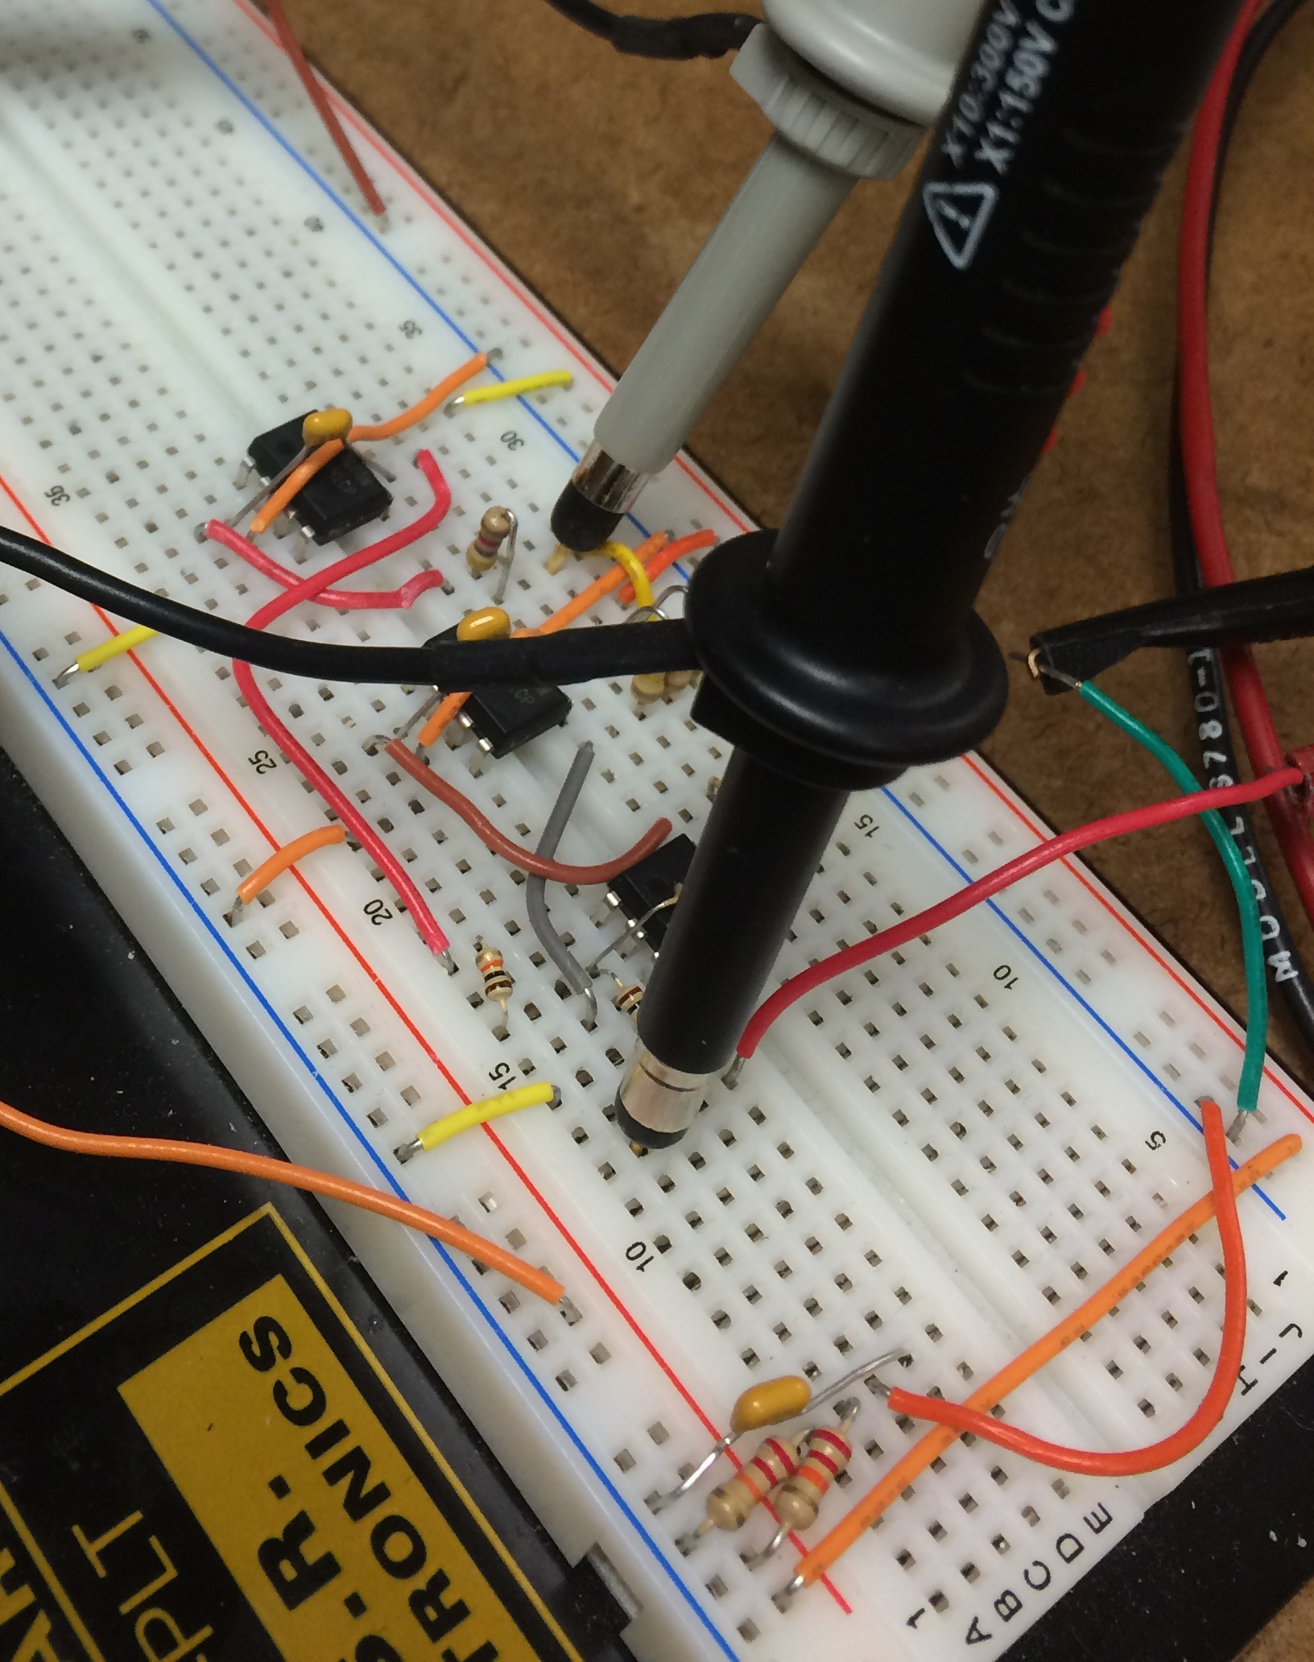

Figure : Breadboard implementation

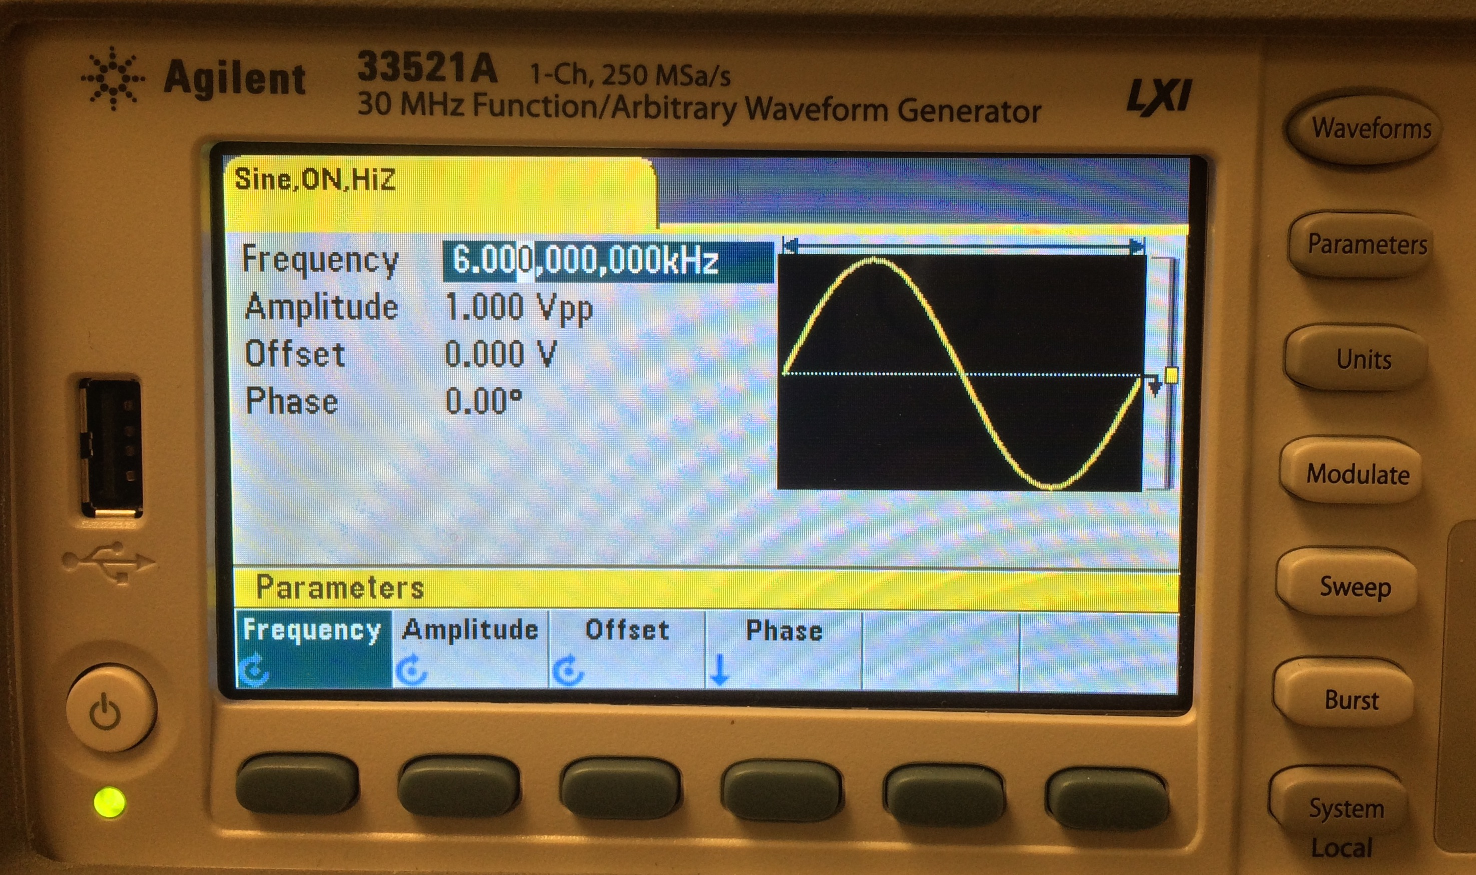

Figure : Function generator parameters

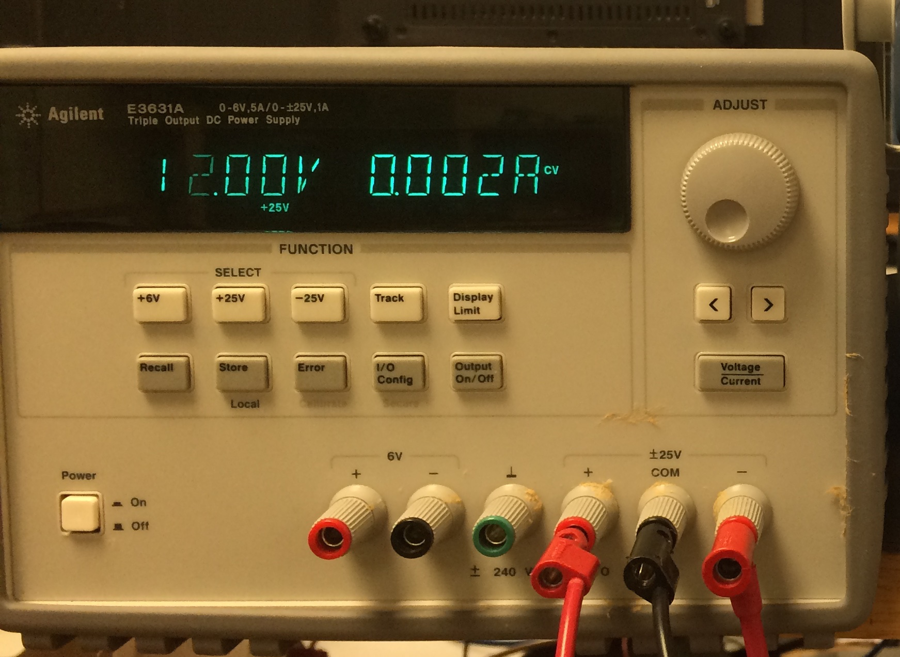

Figure : Power supply setup

The frequency was swept from 100Hz to 100kHz, beginning in a linear sweep within each decade. Two more sweeps, within the determined center frequency were completed in order to better illustrate the filter’s peak. During each sweep, the frequency, output voltage and phase were recorded. Microsoft excel was then used to calculate the filter’s gain in dB. The results of the sweep are shown below.

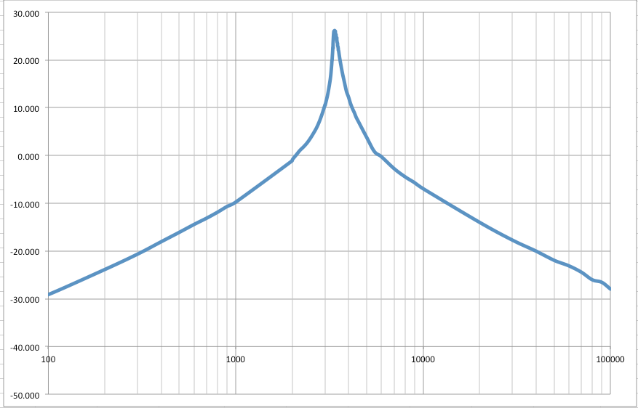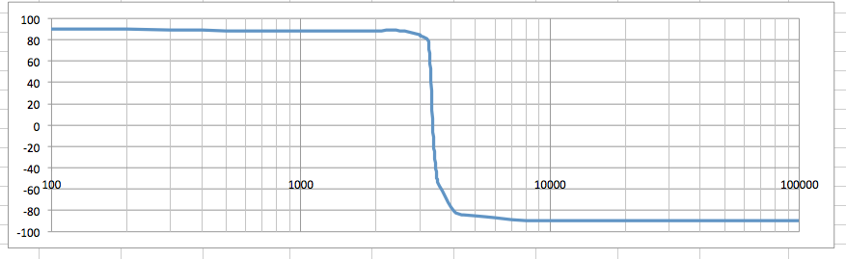

Figure : Experimentally generated bode plot

Finally, the experimentally generated bode plot was compared to the ideal plot generated in MATLAB. The results were combined into one plot, which is shown below. From the very close results, it can be assumed that the constructed plant is well within reasonable error of physical components and is a good implementation of the theoretical plant.

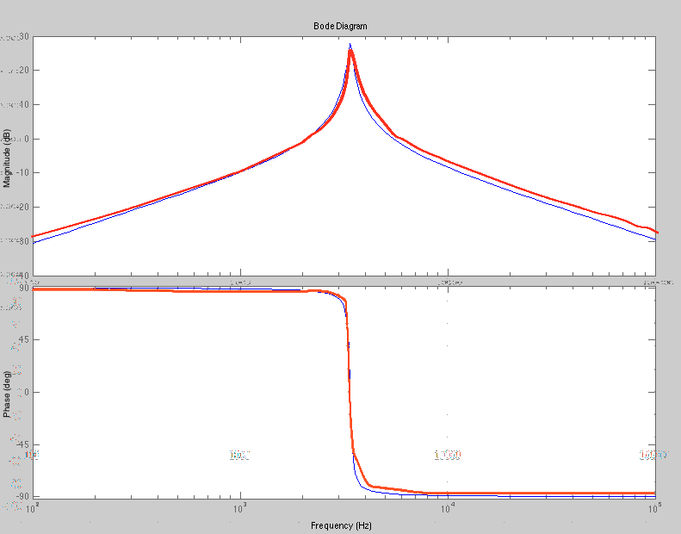

Figure : Comparison of experimental and theoretical data. Ideal is in blue, experimental is in red.